**CURRICULUM VITAE**

**Name:** **JAFFAR ABDULLA MOHAMMED NESAIF**

**CPR number: 870804413**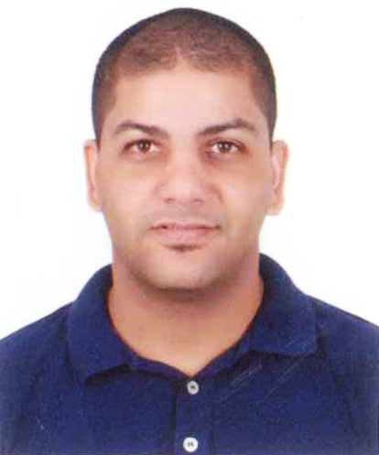

Telephone number:00973 36530746

**E-mail add.: jaff.abdllua87**[**@yahoo.com**](mailto:lorna_misanes@yahoo.com)

**EDUCATION: Jidhafs Public High School**

**TRAININGS:**

March 2, 2016 Heartsaver First Aid CPR AED American Heart AssociationJune 2015 Basic Security Guard Training G4S Secure Solutions Bahrain

July 2013 Workshop "Time Management" Leaders Institute for Training/Development April 2013 Course on Business Writing that Work Brothers Institute

June 2012 Heart saver CPR AED American Heart Association

December 2012 Handling Skills with Hospital Staff Bridge Training Solutions

November 2010 Training Course on How to Use Fire Extinguishers Gen. Directorate of Civil Defense

November 2010 Fire Fighting OSHO Training

April 2016 First Aid CPR and AED Training American Heart Association

**WORK EXPERIENCES:**

**DATE**  **COMPANY DESIGNATION**

June 2015- June 2016 G4S Secure Solutions Bahrain Security-Patrolling

(City Center)

-Best Performer of the month Award

March 2008 – September 2014 International Hospital of Bahrain Security Guard

September 2007 – January 2008 Salman AL Sayegh Construction Driver/Messenger/Writer

May 2018 until now worked at Pepsi

**PERSONAL DATA:**

NAME: Jaffar Abdullah Mohammed Nesaif

CPR Number: 870804413

Date of Birth**:**  30 August 1987

GENDER: Male

CIVIL STATUS: Single

HEIGHT: 175cm

DIALECT SPOKEN: Arabic, English, Indian and Filipino

ADDRESS: Villa 170, Road 5005, Block 450, AL Maqsha, Bahrain

TELEPHONE #: 33979266/ 34398237

DRIVING LICENSE: Private

**SKILLS:**

Interpersonal: Hard working, self motivated and good communication skills.

Computer skills: MS Office, Windows, Programming Language.

**INTERESTS:**

Surfing the internet, Playing Football and Painting.

**REFERENCES:**

Mr. Martyn Hayden Head of Insurance Int’l Hosp. of Bahrain Tel # 17598222

Dr. Yasser Sawaf Gastroenterologist Int’l. Hosp. of Bahrain

Tel# 39253422

Mr. Muhammad Mohsin Project Manager G4S Secure Solutions, Bahrain

Tel# 36899699